Symmetries of a Rectangle
If you take a rectangle and rotate itabout the centre then it looks exactly the same as it did before. We say the rectangle has rotation symmetry.

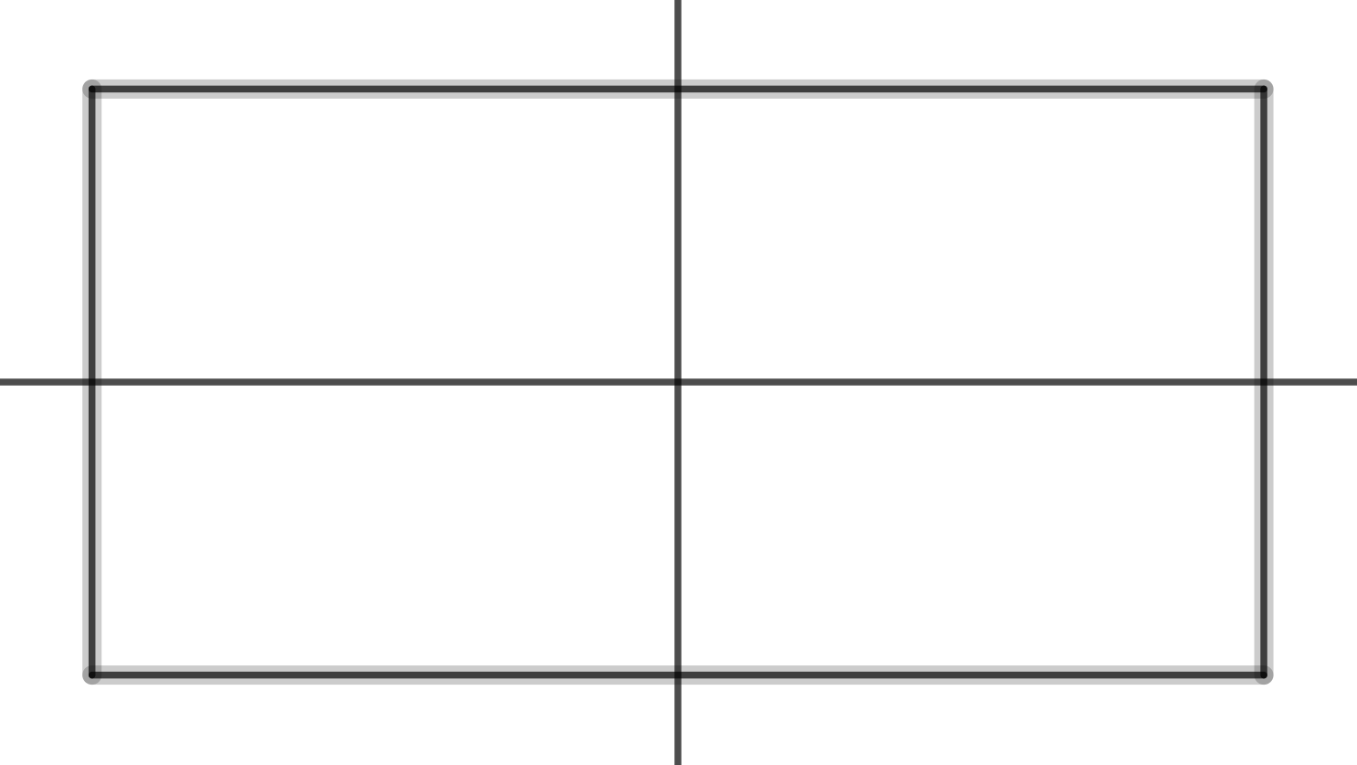

The symmetries of the rectangle are:
do nothing
rotateabout the centre
rotateabout theaxis
rotateabout theaxis

We can combine symmetries.
means you doand then you doThis means you dofirst.
Take a piece of card, in the shape of a rectangle.
If you doand then doit will end up in the same position as if you had just done
Try it.
Sois the same asSo
Here is the combination table. You should check some of these.

*

Note:goes in therow and thecolumn.
The setwith the binary operation * forms a group.

